20170454 Yi Changmin

network-hw6

1. (T/F) Application that needs reliable data transfer must use protocol that guarantees reliability such as TCP protocol.

Answer: False

Application can archive reliable data transfer even though using unreliable protocol such as UDP, by implementing the reliable data transfer functionality at application level.

1. We are sending HTTP request from PC for one file. RTT between PC and proxy server is 10ms, and RTT between proxy server and origin server is 100ms. It takes an average of 90ms to receive the first bit of a response when PC sends an HTTP request. Calculate the hit rate of the proxy server. Ignore the size of the files.

Answer: 0.2

(100 + 10)(1 - p) + 10p = 90, so p = 0.2

1. In picture below, x is sending IPv6 packet to y. The cost is labeled at edges. Edges are bi-directional, and cost is same regardless of direction. Packet must be sent to the path with the lowest cost. Can packet sent by x reach y? All routers are compatible with IPv4, and x, y, A, B, C, H are compatible with IPv6. Assume that a router supporting IPv6 knows whether other routers support IPv6 or not.

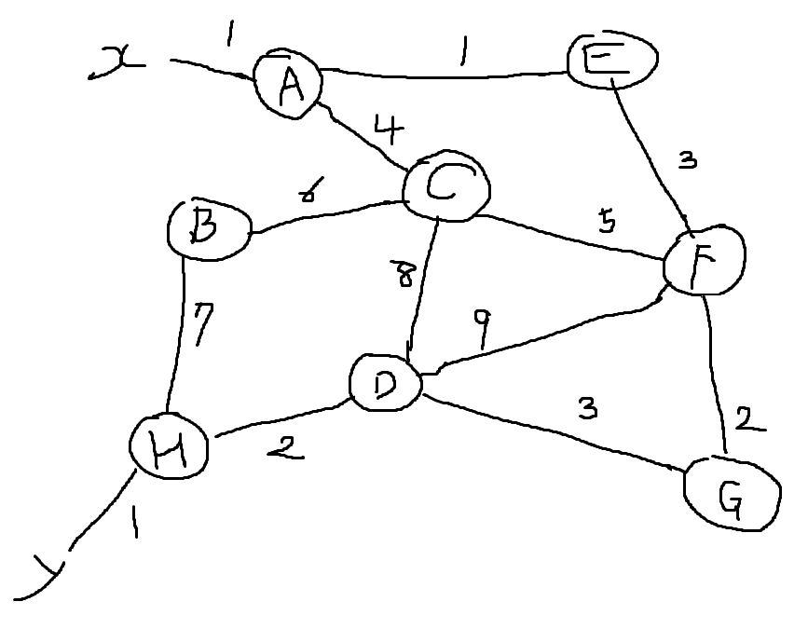Answer: Possible

Shortest path from x to y is x-A-E-F-G-D-H-y, which has minimal cost 13. Among these routes, IPv6 isn’t supported in the E-F-G-D section. So, A encapsulates IPv6 packet with IPv4 packet which has destination H (tunneling) and sends it to H. H receives IPv4 packet from A and decapsulates it, and send original IPv6 packet to y.